ARSITEKTUR & STRUKTUR CODEBASE

1.1 Ringkasan Komponen Utama
Sistem GEMPA AI-TEWS terdiri dari 4 komponen utama:
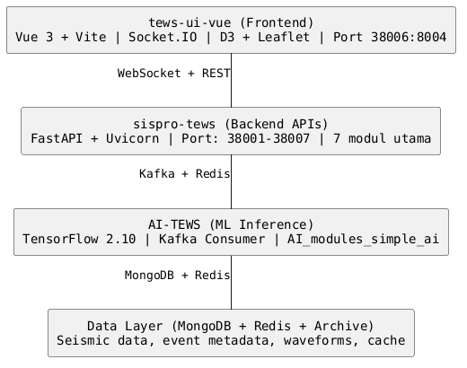

1.2 Rincian Setiap Komponen

A. tews-ui-vue (Frontend Web Application)
Lokasi: ./tews-ui-vue/
Teknologi: Vue 3, TypeScript, Vite, TailwindCSS + DaisyUI
Port: 38006 (eksternal) → 8004 (internal, nginx)
Fungsi:
- Visualisasi real-time gempa dan data seismik
- Dashboard monitoring station, event, phase detection
- Integrasi peta (Leaflet, D3 untuk grafik)
- Koneksi WebSocket ke controller_module untuk live data
- REST API calls ke backend services

Dependencies Utama:
- Vue 3.4.31, Vue Router 4.4.0
- Pinia 2.1.7 (state management)
- Socket.IO-Client 4.7.5 (real-time)
- Axios 1.7.2 (HTTP client)
- D3 7.9.0 (data visualization)
- Leaflet 1.9.4 (mapping)
- TanStack Vue Query 5.51.1 (data fetching)
- date-fns 3.6.0, lodash 4.17.21
Build Process:
npm run build # Output: dist/ folder
# nginx serves /app/dist ke /usr/share/nginx/html
Nginx Config (tews-ui-vue/nginx.conf):
- Listens on port 8004
- SPA fallback: semua route → index.html
- Gzip compression enabled
- Worker processes: 4

B. sispro-tews (Backend - Seismic Data Processing)
Lokasi: ./sispro-tews/
Teknologi: Python 3, FastAPI, Uvicorn, ObsPy, MongoDB driver
Network: External Docker network sispro-tews_req
Port Mapping:
Modul | Port Internal | Port Eksternal | Fungsi
api_incoming_module | 8007 | 38007 | Public API untuk incoming events
record_stream_module | 8001 | 38001 | Streaming seismic records
fdsn_api_module | 8002 | 38002 | FDSN-WS API endpoint
controller_module | 8003 | 38003 | Main controller API + orchestration
websocket_waveform | 8004 | 38004 | WebSocket waveform data stream
websocket_general | 8005 | 38005 | WebSocket general updates
archiving_module | - | - | Background archiving service (no public port)
fdsn_module | - | - | FDSN scheduler (background)
seedlink_module | - | - | SeedLink protocol consumer (background)

Modul Detail:
1. api_incoming_module
- Entry point untuk data eksternal (HTTP POST)
- FastAPI app di api_incoming_module.py
- Wrapper: app_incoming_module.py → uvicorn server (32 workers, port 8007)
- Menerima: earthquake data, station info, picks, associations
2. record_stream_module
- Streaming real-time seismic waveforms
- Port 8001, volume mount ke archive location
- Consumer data dari seedlink atau external sources
3. controller_module
- Orchesterasi seluruh sistem
- Main controller API (FastAPI, port 8003)
- WebSocket untuk client connections
- 3 variants:
  - controller_web_socket_redis.py - Main WebSocket handler (backup & replicas)
  - controller_web_socket.py - Alt implementation
  - controller_api_app.py - API endpoint wrapper
3a. websocket_general (Dockerfile_general)
- Port 8005
- Broadcast general updates (station status, etc.)
3b. websocket_waveform (Dockerfile_waveform)
- Port 8004
- Dedicated waveform streaming (high-frequency data)
- Nginx proxy (sispro-tews/nginx/nginx.conf) routes WebSocket ↔ waveform service
4. fdsn_module + fdsn_api_module
- FDSN-WS (Federated Digital Seismic Network) compliant
- fdsn_api.py - FDSN REST API
- fdsn_scheduler.py - Background scheduler untuk query remote stations
- Volume mount: archive location (read seismic data)
- Port 8002 public, scheduler runs internal
5. archiving_module
- Background daemon, no public port
- Replicates: 7 instances (load-balanced archiving)
- Memory limit: 20 GB per instance
- Fungsi: persist seismic data to MongoDB/disk, cleanup old data
- Volume: ${archive_location} (seismic archive directory)
- Docker socket mount: orchestrate sibling containers if needed
6. seedlink_module
- SeedLink protocol consumer
- Replicates: 5 instances
- Memory limit: 5 GB per instance
- Connects to remote SeedLink servers, streams waveform data
- Docker socket mount: dynamic container orchestration

C. AI-TEWS (Artificial Intelligence Modules)
Lokasi: ./AI-TEWS/
Teknologi: Python 3, TensorFlow 2.10, Kafka, Redis, MongoDB
Versi Aktif: AI_modules_simple_ai
Struktur Directory:
AI-TEWS/
├── AI_modules_alpha/ (experimental, v1)
├── AI_modules_beta/ (experimental, v2)
├── AI_modules_neoalpha/ (experimental, v3)
├── AI_modules_simple_ai/ (RECOMMENDED - production ready)
├── AI_modules_template/ (development template)
├── requirements/ (shared dependencies: Kafka, Redis, MongoDB setup)
├── archive/ (waveform data cache)
└── dump.rdb (Redis persistence snapshot)
AI_modules_simple_ai Components:
1. p-pick_module (P-wave Phase Picker)
- Teknologi: TensorFlow 2.10 (neural network model)
- Memory: 5 GB per instance, 5 replicas
- Service (p-pick_module/service/):
  - Flask/Gunicorn server (port 8000 internal)
  - Model inference engine
  - Requirements: tensorflow==2.10, keras, numpy, scipy
- Nginx Load Balancer (p-pick_module/nginx/):
  - Distributes requests to 5 service replicas
  - Nginx config: load balancing upstream
- Consumer (p-pick_module/consumer/):
  - Kafka consumer: listens to “event” topic
  - Posts waveform data to p-pick service via HTTP
  - Publishes results back to Kafka
- Ports:
  - Service: 8000 (internal, no external exposure - behind nginx)
  - Nginx: configurable via ${nginx_port} in .env (default: 80)
2. association_module
- Event-phase association algorithm
- PyOcto/custom algorithm
- Consumes picks from Kafka, publishes associated events
3. phase-arrival_module
- Phase arrival time prediction
- Velocity models, travel time calculations
4. locmag_module
- Location and magnitude estimation
- Hypocenter determination using triangulation
- Magnitude calculation from amplitude
Requirements File (AI-TEWS/AI_modules_simple_ai/p-pick_module/service/requirements.txt):
kafka_python==2.0.2
obspy==1.4.0
pymongo==4.6.2
python-dotenv==1.0.1
redis==3.5.3
tensorflow==2.10
pandas==1.4.4
tqdm==4.66.4
flask
gunicorn
Docker Compose (AI-TEWS/AI_modules_simple_ai/docker-compose.yml):
- Services: p-pick_service, p-pick_nginx, p-pick_consumer, association_module, phase-arrival_module, locmag_module
- Environment: CUDA_VISIBLE_DEVICES=-1 (CPU-only; set to 0 for GPU if available)
- Dependencies: .env file for Kafka, Redis hosts

D. Infrastructure & Data Layer
1. MongoDB
- Container: Managed via sispro-tews network
- Port: 27017 (internal), 27018 (external, per memory)
- Data: ./data/ folder (WiredTiger database files)
- Collections:
  - stations - Network/station metadata
  - events - Earthquake events (origin, magnitude, etc.)
  - picks - Phase picks (P, S arrivals)
  - associations - Event-phase associations
  - waveforms - Seismic waveform snippets
  - metadata - Catalog metadata
2. Redis
- Role: Cache layer, session store, Kafka offset tracking
- Port: 6379 (internal)
- Persistence: AI-TEWS/dump.rdb (RDB snapshot)
- Data structure: Strings (cache), Hashes (state), Lists (queues)
3. Kafka
- Message broker for inter-service communication
- Topics: event, pick, association, waveform
- Ports: configurable (internal)
- Used by: AI modules (consumers), archiving (producers), controller (bidirectional)
4. Archive Storage
- Volume mount: ${archive_location} (local filesystem)
- Stores: Raw seismic waveforms (miniSEED format)
- Size: ~1-2 TB typical (depends on station count & retention)
5. Data Files
- ./data.zip - MongoDB backup (compressed, ~1.8 MB)
- ./data/ - Expanded MongoDB data (WiredTiger storage engine)
- AI-TEWS/dump.rdb - Redis persistence (RDB format, ~1 KB)

1.3 Data Flow (Alur Data Sistem)
1. INCOMING DATA STREAM
├─ External SeedLink Servers
│ └─→ seedlink_module (5x) ─→ Kafka topic: "waveform"
├─ HTTP POST (api_incoming_module:38007)
│ └─→ FastAPI ─→ Validate ─→ MongoDB + Kafka: "event"
└─ FDSN-WS Query (client calls fdsn_api_module:38002)
└─→ Query MongoDB, return FDSN-format response
2. AI INFERENCE PIPELINE
├─ P-pick Service (5x replicas)
│ ├─ Consumer reads Kafka: "waveform"
│ ├─ POST to p-pick_nginx (load-balanced)
│ ├─ Model inference (TensorFlow GPU/CPU)
│ └─ Publish Kafka: "pick"
├─ Association Module
│ ├─ Consumes: "pick"
│ └─ Publishes: "association"
├─ Phase-Arrival Module
│ └─ Refines picks with travel time
└─ LocMag Module
└─ Calculates hypocenter, magnitude
3. ARCHIVING & PERSISTENCE
├─ Archiving Module (7x) reads Kafka: "waveform"
│ ├─ Write to MongoDB (events, picks, associations)
│ ├─ Write to filesystem archive (miniSEED)
│ └─ Update Redis cache
└─ FDSN Module periodically syncs remote stations
4. REAL-TIME FRONTEND UPDATES
├─ Controller Module (orchestrator)
│ ├─ Polls MongoDB for new events
│ ├─ Aggregates system status
│ └─ WebSocket broadcast (socket.io)
├─ websocket_general:38005 ─→ Browser (general updates)
├─ websocket_waveform:38004 ─→ Browser (waveform plot data)
└─ Frontend: Vue app consumes via socket.io-client
5. CLIENT QUERIES
├─ HTTP GET /api/events?bbox=... (controller_module:38003)
├─ HTTP GET /fdsnws/event/1/query? (fdsn_api_module:38002)
├─ HTTP POST /api/event (api_incoming_module:38007)
└─ WebSocket: /socket.io/ (controller + websocket modules)
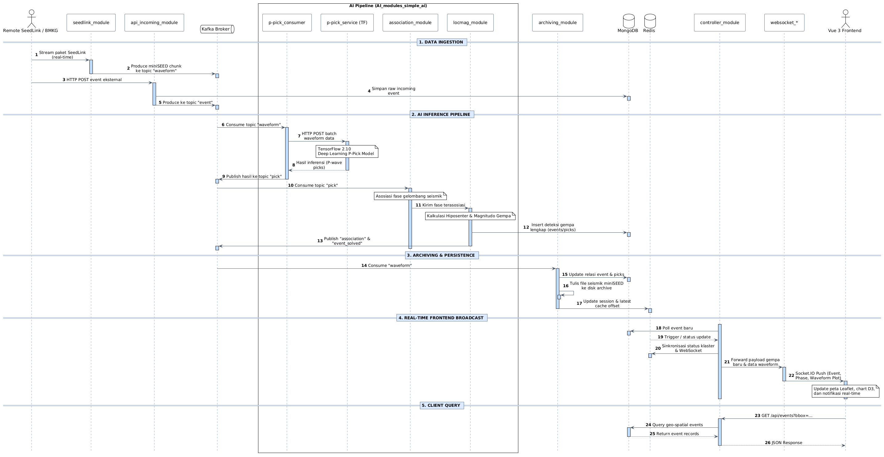

1.4 Komunikasi Inter-Service
Source | Destination | Protocol | Data | Port
seedlink_module | Kafka | Kafka | Waveform | 9092
p-pick_service | Kafka | Kafka | Picks | 9092
archiving_module | MongoDB | TCP | Event metadata | 27017
controller_module | Redis | TCP | Cache/state | 6379
websocket_* | Frontend | WebSocket | Live data | 8004, 8005
Browser | controller_module | HTTP REST | Queries | 38003
Browser | fdsn_api_module | HTTP FDSN | FDSN queries | 38002
External | api_incoming_module | HTTP REST | New events | 38007

1.5 Network & Volumes
Docker Network: sispro-tews_req (external, pre-created)
- All sispro-tews services + AI services connected
- Cross-service hostname resolution: service_name:port
Volumes:
- ${archive_location} - Seismic archive (host path, mounted R/W)
- /var/run/docker.sock - Docker socket (archiving_module, seedlink_module)
  - Purpose: Orchestrate sibling containers (scaling, cleanup)

Environment Variables (.env):
- archive_location - Host path for archive storage
- archive_replica_count - Archiving module replicas (default 7)
- seedlink_replica_count - SeedLink module replicas (default 5)
- kafka_host, kafka_port - Kafka broker
- redis_host, redis_port - Redis connection
- database_host, database_port - MongoDB connection
- nginx_port - Nginx port (AI modules)

